ProcessMind AI
Autonomous Process Intelligence Platform
Transform SOPs into Intelligent, Validated, Simulated, Optimized, and Executable Business Processes

1. Executive Summary
ProcessMind AI is an AI-powered Process Intelligence Platform that enables organizations to transform static Standard Operating Procedures (SOPs) into intelligent, executable, and continuously optimized business processes.
Unlike traditional workflow automation tools that require users to manually design workflows, ProcessMind AI uses Artificial Intelligence to:
- Understand SOPs
- Generate workflows automatically
- Validate process logic
- Simulate process outcomes
- Execute workflows
- Monitor execution
- Analyze bottlenecks
- Recommend optimizations
The platform serves as an AI Process Architect, Process Auditor, Process Simulator, Workflow Engine, and Process Optimization System.
Its long-term vision is to become an AI Operating Layer for organizations.

2. Problem Statement
Organizations store operational knowledge in:
- SOP documents
- Policy manuals
- PDF files
- Word documents
- Internal documentation

These documents define how business processes should operate.
However:
- SOPs are not executable
- Employees manually follow procedures
- Process bottlenecks remain hidden
- Approval chains create delays
- Compliance risks are difficult to identify
- Workflow optimization requires expensive consultants
Traditional platforms such as workflow builders focus on execution rather than understanding and improving processes.
Organizations therefore lack a system capable of transforming business knowledge into operational intelligence.

3. Vision
To build the AI Operating Layer for Organizations.
ProcessMind AI will understand:
- Business Processes
- Policies
- Organizational Structure
- Departments
- Approval Chains
- Dependencies
- Operational Rules
and continuously improve how organizations operate.

4. Mission
Convert organizational knowledge into intelligent operational systems.
ProcessMind AI bridges the gap between:
Business Knowledge
↓
Process Intelligence
↓
Workflow Execution
↓
Continuous Optimization

5. Core Value Proposition
Traditional Workflow Platforms
Human Designs Workflow
↓
Platform Executes Workflow
Examples:
- n8n
- Zapier
- Power Automate
ProcessMind AI
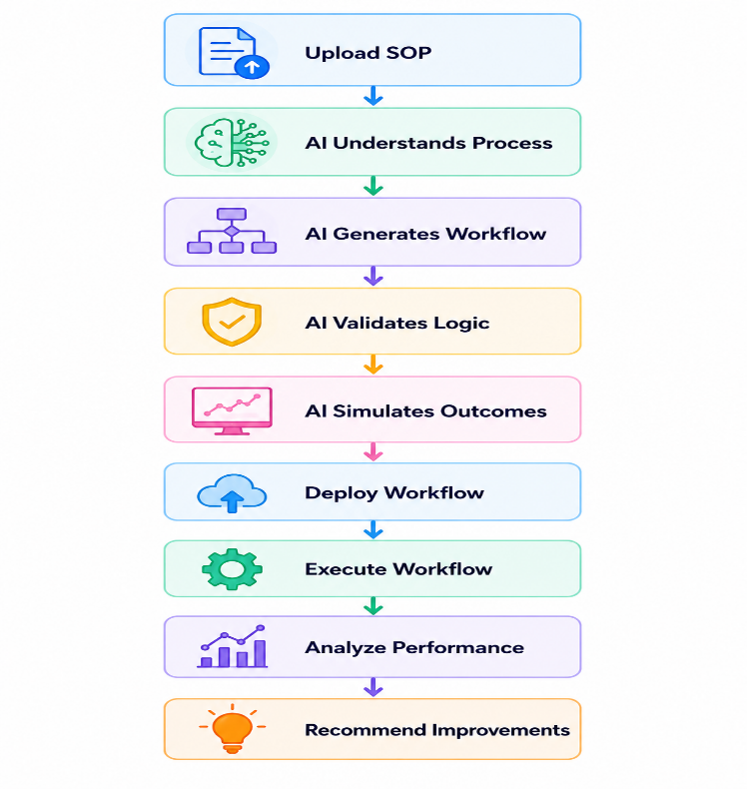

The platform focuses on Process Intelligence, not merely automation.
6. Target Customers
Small and Medium Businesses
Organizations that have SOPs but lack workflow automation expertise.
Enterprise Departments
- Human Resources
- Finance
- Procurement
- Operations
- Compliance
- IT Services
Consulting Firms
Organizations involved in business process optimization.
Government Organizations
Departments with SOP-driven operations.
7. Product Modules
Module 1: SOP Intelligence Engine
Purpose
Convert SOP documents into structured process definitions.
Input Formats
- Plain Text
- PDF
- DOCX
AI Responsibilities
- Condition Extraction
- Action Extraction
- Approval Detection
- Role Identification
- Dependency Detection
- Risk Detection

Example
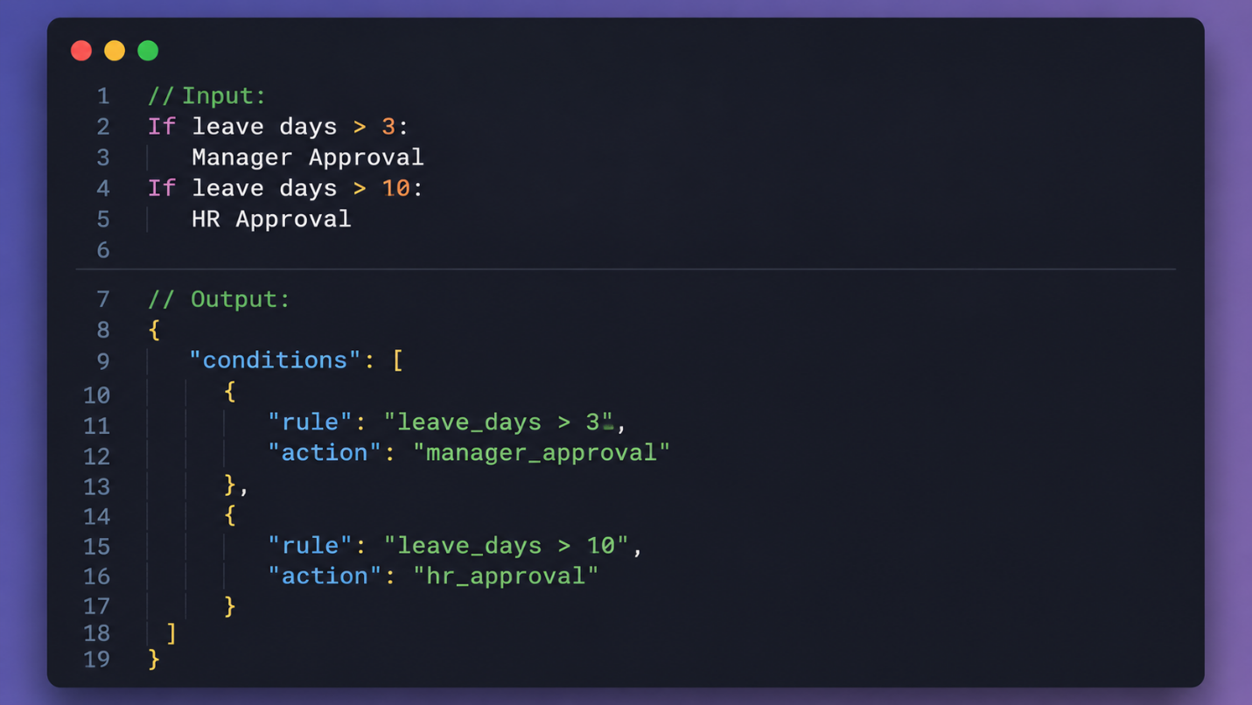
Module 2: Workflow Generation Engine
Purpose
Automatically generate workflows from SOPs.
Output
Visual workflow diagrams.
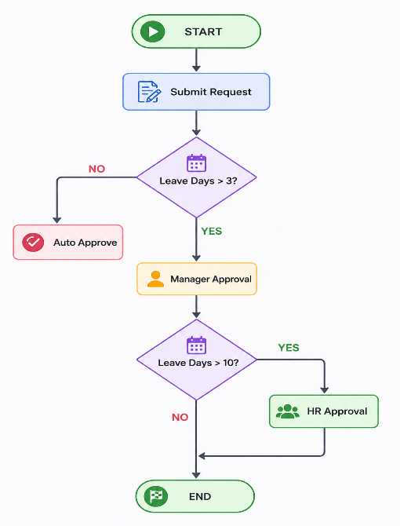
Features
- Decision Trees
- Approval Chains
- Dependency Mapping
- Workflow Visualization
Module 3: Process Validation Engine
Purpose
Detect process design issues before deployment.
Validation Rules
- Missing Approvals
- Undefined Roles
- Circular Dependencies
- Rule Conflicts
- Compliance Risks
- Ambiguous Conditions
Example
AI Report:
Potential Conflict Detected
Invoices > $10000
satisfy both rules:
Manager Approval
CFO Approval
Recommended Sequence:
Manager → CFO
Module 4: Process Simulation Engine
Purpose
Allow organizations to test workflows before deployment.
Capabilities
- Scenario Testing
- Outcome Prediction
- Approval Forecasting
- Completion Time Estimation

Example
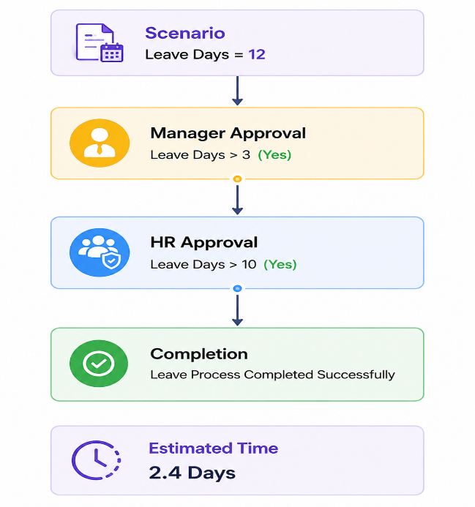

Module 5: Workflow Execution Engine
Purpose
Execute workflows dynamically.
Responsibilities
- State Management
- Workflow Routing
- Workflow Tracking
- Pause and Resume
- Workflow Completion
States
DRAFT
ACTIVE
RUNNING
WAITING_APPROVAL
COMPLETED
FAILED

Module 6: Human Approval Engine
Purpose
Manage approval-based processes.
Features
- Approval Requests
- Escalation Management
- Deadline Tracking
- SLA Monitoring
- Approval Audit Trail

Module 7: Process Analytics Dashboard
Purpose
Provide operational visibility.
Metrics
- Active Processes
- Completion Rates
- Approval Delays
- Failure Rates
- Average Completion Time
- Workflow Utilization
Dashboard Insights
Top Delayed Process:
Procurement Approval
Average Delay:
4.2 Days

Module 8: AI Process Optimization Engine
Purpose
Continuously improve business processes.
AI Analysis
- Bottleneck Detection
- Redundant Approval Detection
- Process Simplification
- Delay Analysis
Example
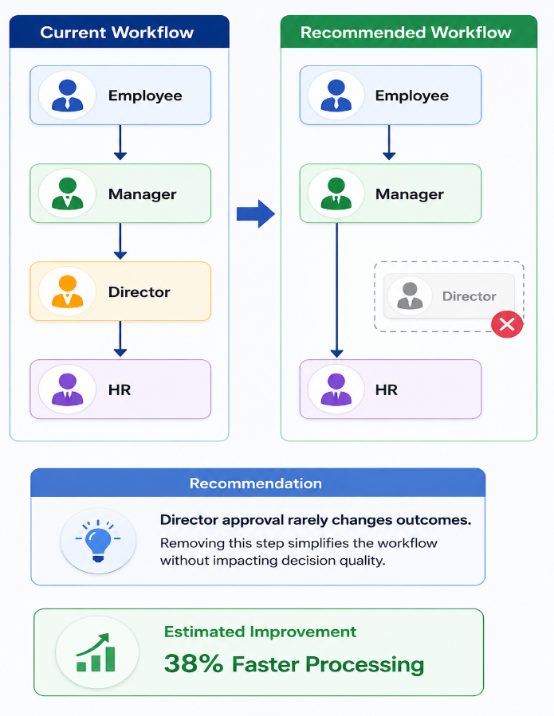

8. MVP Use Case
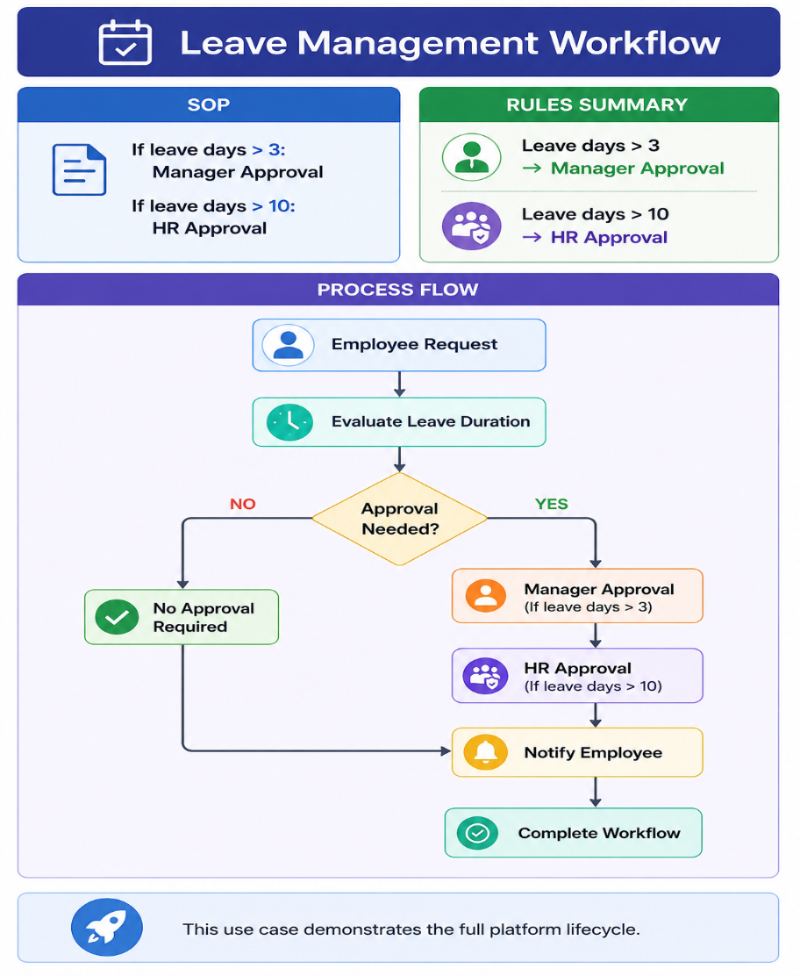

9. Future Advanced Modules
Organizational Knowledge Graph
Purpose
Store organizational relationships.
Entities
- Employees
- Departments
- Policies
- Processes
- Systems
- Approvals

Benefits
Answer questions like:
Which workflows require HR?
Which process depends on Finance?
Which policy affects onboarding?

Organizational Digital Twin
Purpose
Create a virtual representation of organizational operations.
Capabilities
Simulate changes before implementation.
Example:
What happens if HR approval is removed?
What happens if approval threshold changes?
AI predicts outcomes.
Multi-Agent Intelligence Layer
SOP Agent
Parses SOPs.
Architect Agent
Designs workflows.
Validator Agent
Validates process logic.
Simulator Agent
Runs simulations.
Executor Agent
Executes workflows.
Recovery Agent
Handles failures.
Analytics Agent
Generates insights.
10. Future Use Cases
Human Resources
- Leave Management
- Employee Onboarding
- Performance Reviews
- Employee Offboarding
Finance
- Invoice Approval
- Expense Claims
- Budget Approvals
Procurement
- Purchase Requests
- Vendor Approvals
- Contract Reviews
Compliance
- Policy Reviews
- Risk Assessments
- Audit Processes
IT Operations
- Incident Management
- Access Requests
- Change Management

11. System Architecture
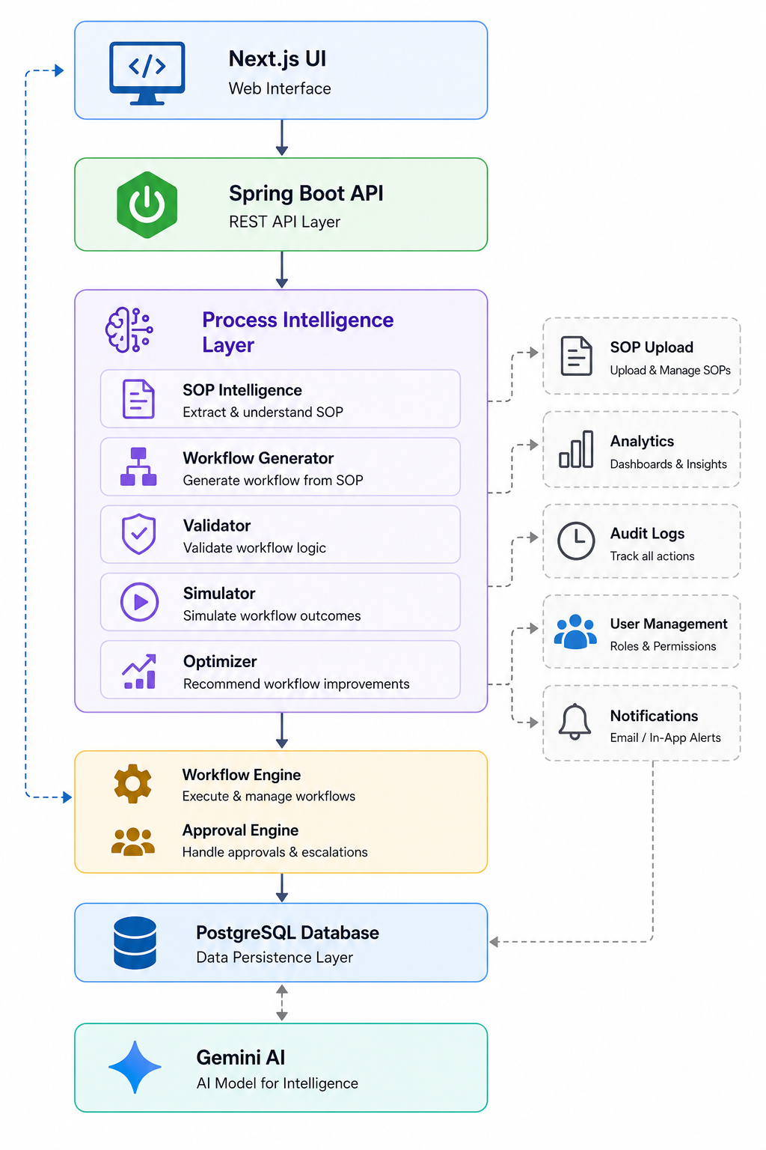

12. Technology Stack
Frontend
- Next.js
- React
- TypeScript
- Tailwind CSS
- React Flow
Backend
- Java 21
- Spring Boot
- Spring Security
- Spring Data JPA
- Hibernate
- JWT Authentication
Database
- PostgreSQL
Hosted using:
- Neon PostgreSQL
Artificial Intelligence
- Gemini 2.5 Flash (MVP)
- Gemini 2.5 Pro (Future)
Uses AI for:
- SOP Understanding
- Validation
- Simulation
- Optimization
Not for workflow execution.

Containerization
- Docker
- Docker Compose

Deployment
Frontend:
- Vercel
Backend:
- Render
Database:
- Neon

13. Security Architecture
Authentication
- JWT Authentication
- Spring Security
Authorization
- Role-Based Access Control (RBAC)
Roles:
- Employee
- Manager
- Administrator
Security Features
- BCrypt Password Hashing
- HTTPS
- Input Validation
- Audit Logs
- Environment Variables

14. Revenue Model
Free Plan
- Limited SOPs
- Limited Simulations
Professional Plan
$49/month
Includes:
- SOP Intelligence
- Workflow Generation
- Validation
- Simulation
- Analytics
Business Plan
$99/month
Includes:
- Team Collaboration
- Workflow Deployment
- Advanced Analytics
Enterprise Plan
Custom Pricing
Includes:
- SSO
- Multi-Tenant Deployment
- Custom Integrations
- Dedicated Support

15. Competitive Advantages
Unlike traditional workflow tools:
✅ Understands SOPs automatically
✅ Generates workflows automatically
✅ Validates business logic
✅ Simulates process outcomes
✅ Provides optimization recommendations
✅ Enables organizational intelligence
✅ Supports future digital twin architecture

16. Long-Term Vision (2030+)
ProcessMind AI evolves into an AI Organizational Operating System.
The platform will:
- Understand organizational knowledge
- Simulate organizational decisions
- Continuously optimize operations
- Build digital twins of business processes
- Enable autonomous operational intelligence
17. Success Criteria
The platform is successful when it can:
✅ Parse SOPs accurately
✅ Generate workflows automatically
✅ Validate process logic
✅ Simulate outcomes
✅ Execute workflows
✅ Monitor workflow performance
✅ Identify bottlenecks
✅ Recommend optimizations
✅ Support multiple business domains
✅ Deliver measurable operational improvements
Final Product Statement
ProcessMind AI is an Autonomous Process Intelligence Platform that converts organizational knowledge into intelligent, validated, simulated, optimized, and executable business processes, enabling organizations to operate faster, smarter, and more efficiently.

